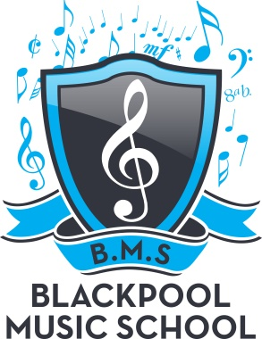

SINGALONG
EVERY
WEDNESDAY
1.00pm– 3.00PM
£4.00 per week
SINGING WILL LIFT YOUR SPIRITS
WHY NOT JOIN US!
420 WATERLOO RD – FY4 4BL
RING – 01253 695398
info@blackpoolmusicacademy.co.uk

